
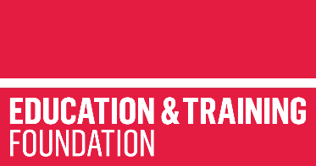

CASE STUDY
HAVANT AND SOUTH DOWNS COLLEGE

ET-FOUNDATION.CO.UK

CASE STUDY

All fields are mandatory

Author | Ashley Grute
Date | 25 March 2022
Name of provider/institution | Havant and South Downs College
Title | Partnership approaches to developing effective Health and Nursing T Level placements
Word count  (Minimum = 500  Maximum = 2000) | 1024 words excluding titles
Have all materials (i.e. the case study, images and supporting files of evidence) been copyright-cleared via a signed permission form?  (If yes, enter the number of permission forms that have been submitted with this case study) | Not required.
Case study title | Bringing the health T Level to life
Summary  (Enter summary of case study – one paragraph of approximately 80 words) | This collaborative project sought to jointly develop a research pack, letter templates, local processes and Standard Operating Procedures, to link these to the T Level curriculum and ensure therefore that the students on programme receive training fully in line with the actual processes, enabling them to hit the ground running once on placement or when moving into employment.
About the Colleges | The TRIP lead partner, Havant and South Downs College, is a leading Further and Higher Education College providing learning across three campuses in Hampshire - Alton, Havant & South Downs. The College was an early adopter of T Levels, seeing them as an important and interesting addition to their offer. Their position in Hampshire makes them a potential key strategic partner of some significant NHS Trusts.  The partner colleges included Abingdon and Witney College, Isle of Wight College and Newbury College. Like HSDC, A&W implemented Health T Levels in 2021, and the others will in 2022.
The context (relevant background information and circumstances) | With the backdrop of COVID-19 making access to the NHS really difficult the team had to be resourceful and resilient.  Together they developed templates and forms to send to all local contacts with the aim of gaining access to systems and processes that the team could use as the basis of the learning materials.  The aim of the project was to set up mirrored resources within the FE colleges using exact systems and procedures to enable the students to be able to hit the ground running on placement and when moving into employment.  NHS engagement remains a challenge around T Levels, but this TRIP has enabled the partners to gain successes in this area by ensuring that the students in learning have a ‘real’ understanding of the precise systems in use locally. This is going to be so important as we move out of the pandemic.
Case Study (main body of text – the story of activity. Please include interesting quotes) | Bringing together four colleges at varying stages of implementing T Levels in Health and Nursing, this TRIP sought to share resources and support in what was recognised as a tricky vocational area (due to COVID-19).  The TRIP initially researched what had gone before and brought in good practice related to recruitment and selection from the Cambridge NHS Trust. Working together, the partners used the T Level specification to generate wish lists of systems and processes that would directly link to the curriculum delivery required.  The group standardised communications to be used to engage local employers.  The templates for letters and emails were used to generate interest in the T Levels and access to resources.  Despite considerable effort on behalf of the partners, communication was still extremely difficult as hospitals were on Code Black due to COVID-19.  That said breakthroughs happened.  The project succeeded in:  - Gaining an array of NHS resources that could be mapped to the curriculum and used in lesson planning, resource development and delivery.  - Establishing contacts and early relationships with NHS Trusts and other employers, resulting in positive impact.  - Developing a platform of collaboration between the colleges to support development and delivery in partnership.  - Collaborations between NHS professionals and HEIs to evaluate and help further develop the lesson resources.  - Showcase the resources to current students to enrich their learning.  The mirrored resources were set up and used in the FE College wards. The wards were officially ‘opened’ and local NHS Trusts and other employers attended. They spent time with the students seeing the facilitates in actions.  The guests were ‘blown away’ by the T Level students in terms of their professionalism and knowledge. Comments included that they could see how important these students will be as part of the workforce of the future. Regular contact is now in place and working groups have been set up to discuss the development of a framework for Industry Placements across the Trust and Hospitals.  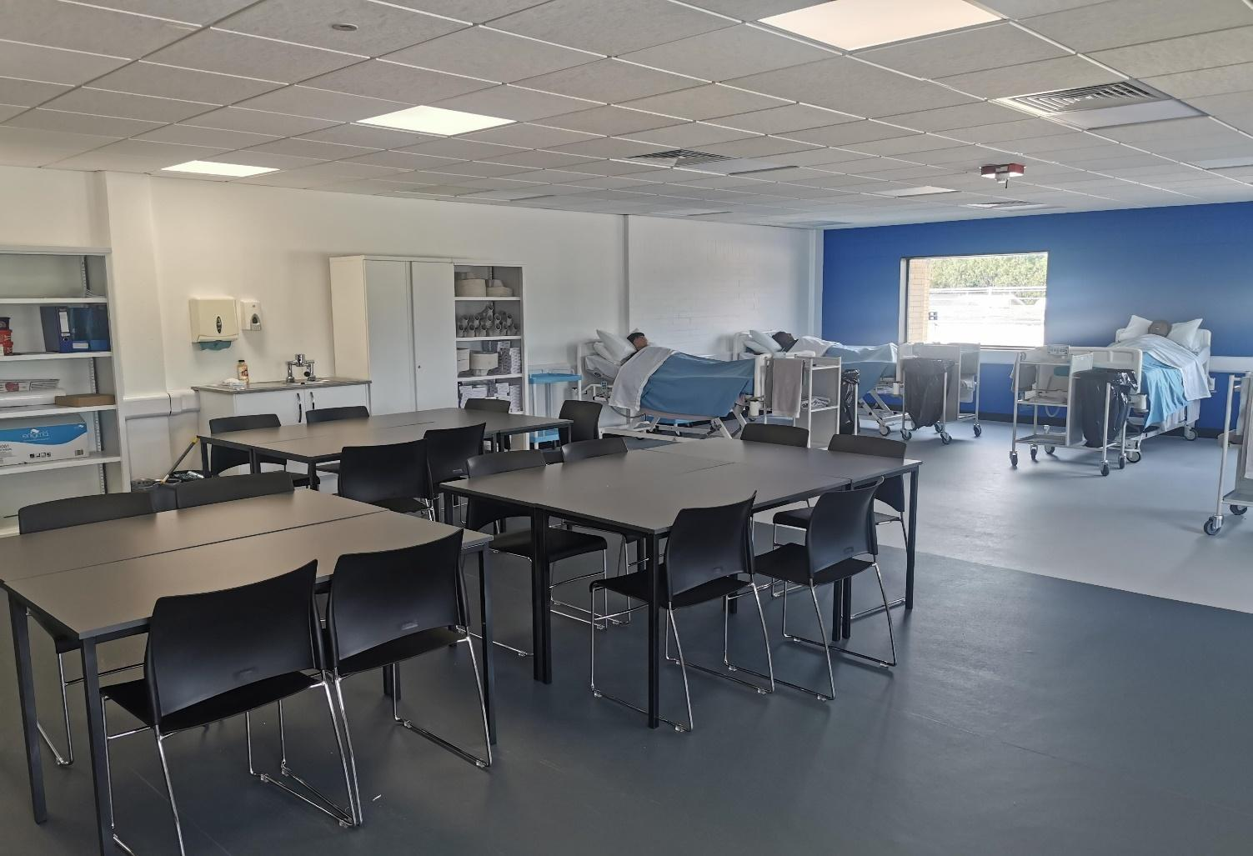  “I left feeling inspired by these students”  “Students are already displaying the professionalism of student nurses”
The outcomes | Through tenacity and perseverance the teams managed to make links with their local NHS related representatives. These led to access to systems and processes which were converted to useful learning resources, mapped to the curriculum. These outputs are housed in 3 folders which contain the following:  Folder 1  - Case studies on the project from Isle of Wight College, Abingdon and Whitney College and HSDC.  - Placement Paperwork taken from Cambridge NHS Trust who have piloted T Level Placements  - Placement Paperwork from IoW college the ’Health Passport’  - Research Preparation guide listing all of the documentation and information as partners we aimed to gather  - Introductory letter to NHS Trusts and organisations from our project group.  Folder 2  - Policy Documents: the Portsmouth Hospitals Nutrition Policy, Portsmouth Hospitals Uniform Policy and the HSDC T Level Uniform policy based upon this.  - Post-Operative Care: Patient Information post-surgery and linked lesson resources  - Vital Signs: NEWS template and scoring system, Portsmouth ViEWS Vital Signs chart. Associated lesson resources and Evaluation Sheet.  - Maternity Resources: A selection of forms used by Maternity departments to include admission records, ultrasound records, birth records and MEWS score charts.  Folder 3  - Curriculum Models for Year 1 T Level Health from IoW, Abingdon and Whitney College and HSDC. This includes sample timetables, practical session outlines, and topic planners to cover the Core Content.  - Scheme of work on Care in Later Life HSDC: To include lesson resources, resources gathered from local NHS Trusts to support learning and evaluations from each session.  - Student Project Plans Abingdon and Whitney: To include practical skills sessions, dementia and safeguarding project plans
The impact  (Please include impact upon individuals, learners and organisations) | The impact of this TRIP has been:  - Close working relationships across the four colleges, enabling motivation and support through really testing times.  - Raising the profile of T Levels locally with employers and HEIs.  - Accurate mirroring of systems, processes and resources between FE and employment.  - Development of high quality, effective and accurate teaching resources.  - Links to future workforce development plans to access IPs and ongoing employment for students.  - The development of processes to sign up students as Bank staff, to enable their continued skills development, the opportunity for paid work and the continuation of the IP experience.
Useful links | https://www.linkedin.com/posts/emily-pease-5a3318135_some-of-the-fantastic-hsdc-t-level-nursing-activity-6905213793912385536-cujK
Disclaimer | The Education and Training Foundation may refer to specific products, processes or services. Such references are examples and are not endorsements or recommendations and should not be used for product endorsement purposes.

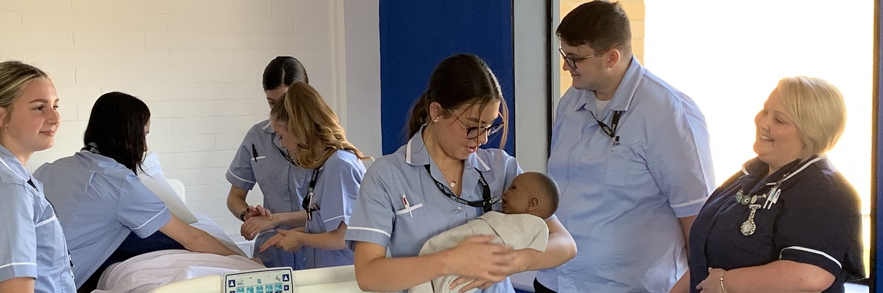



PRODUCED
This programme is funded by
the Department for Education
Havant and South Downs College has produced this resource on behalf of the Education and Training Foundation
FUNDED BY
BY

