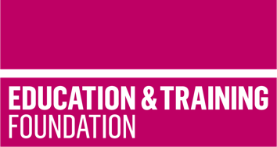
TRIP 14
Brief 3: Materials to support the formative assessment of Core Knowledge content for the T Level in Animal care and management
This T Level Resource Improvement Project (TRIP) has produced a range of learning materials, developed by an experienced T Level provider. These learning materials will support providers to monitor learner progress and support learners to develop their understanding of the Core Content of the T Level in Accounting.
The resources have been produced by Moulton College. The TRIP focusses on formative assessment of learners understanding of Core Content, particularly in relation to:
- AO2 – Apply knowledge and understanding of contexts, concepts, theories and principles to different situations and contexts.
- AO3 – Analyse and evaluate information and issues related to contexts, concepts, theories and principles to make informed judgements.
There are 30 questions included in this resource: 20 AO2 questions and 10 AO3 questions. The questions address the following Core Content Areas:
- Core Content 1: Health and safety
- Core Content 3: Working in the agriculture, environmental and animal care sector.
For each question there is an example of a model answer and an answer that requires further development.
In the AO3 section of the resources, there are also development activities that can be used to support learners to improve their understanding of content and their ability to demonstrate that understanding through responses to exam style questions. For example, there are activities related to producing an effective conclusion or discussion. There are 10 such development activities.

Downloadable resources
Word document including introduction, questions and development activities | 1

