


Hertford Regional College – motor vehicle TRIP resources

Please note that this project has created a range of interactive nearpod resources. These are editable and can be saved on providers’ own nearpod accounts.

If a provider does not have a nearpod account, there are static presentation versions available. These are a large file size due to the inclusion of animations and video.

I have a copy of the three interactive nearpod lessons on my nearpod account and can share these with other people who have a nearpod account.

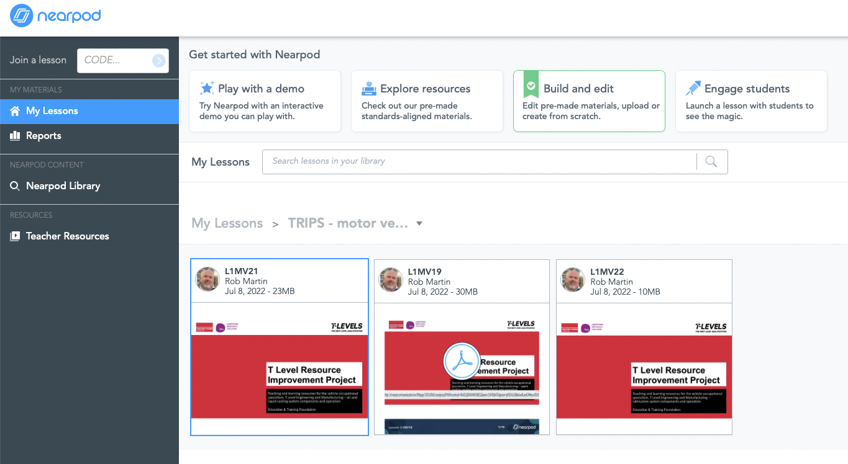


PRODUCED
This programme is funded by
the Department for Education
FUNDED BY
BY

Hertford Regional College has produced this resource on behalf of the Education and Training Foundation

