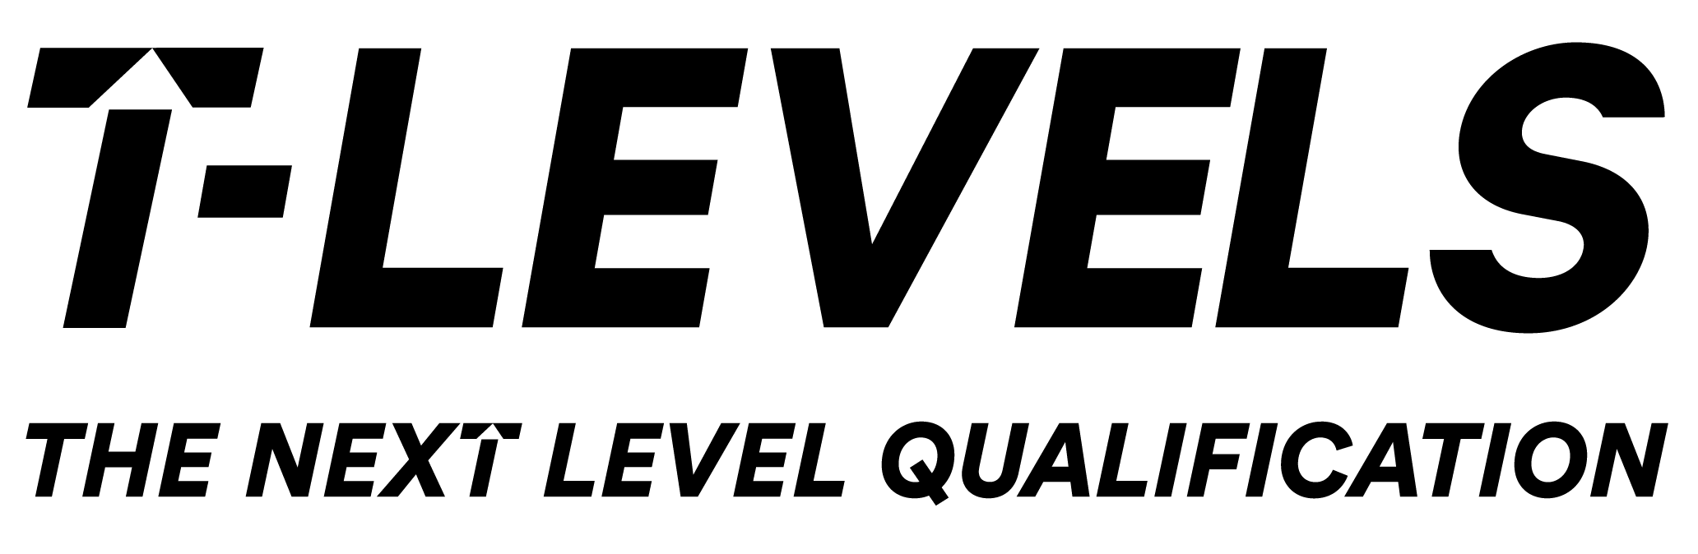
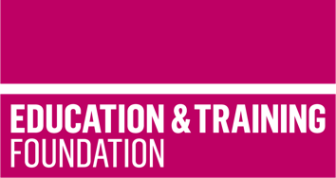

TRIP 3

Materials to support the development of the Core Skill of Presenting for the T Level in Health

This T Level Resource Improvement Project (TRIP) has produced a range of learning materials, developed and peer reviewed by experienced T Level providers. These learning materials will support learners to develop the Core Skill of Presenting for the T Level in Health.

Produced by Calderdale College and peer reviewed by Walsall Academy, this TRIP provides an accessible framework for learning, lesson plans and supporting learning materials that will enable learners to hone and develop their Core Skill of Presenting when developing understanding of the Core Content of the T Level in Health.

The resources include:
- a framework for learning to show how the development of the skills of Presenting can be scaffolded and sequenced
- 11 lesson plans which cover more than 20 hours of learning to support the development of the Core Skill of Presenting in conjunction with Core Content
- learning materials to support each lesson which enables the delivery of the learning framework for learning
- guidance that can be provided to learners to demonstrate how they can use their skill as part of the Employer-set project (ESP) assessment.

The framework sets out one approach to scaffolding and sequencing the development of verbal presentation skills. It focuses on developing the skills needed to deliver effective presentations using non-digital and digital tools that support delivery. This resource also supports the development of verbal and non-verbal communication skills, confidence in delivering presentations, digital skills and health-related knowledge.

The resource focuses on presenting information related to nursing, but this resource could be replicated and used in a variety of healthcare settings. The overall outcome of the learning from this resource is to present information effectively to specified stakeholders.
The resource has been developed for use towards the end of the delivery of the Core Content and assumes prior knowledge of a range of concepts related to nursing.
In addition to lesson plans for each lesson in the framework for learning there are support materials including role plays, case studies and documentation such as medical charts. There are also templates, for peer- and self-assessment with many of the lessons designed to encourage the use of these as part of a formative assessment strategy.

There is a separate slide deck that can be used to support delivery of the lessons.

The framework for learning and lesson plans also cover the following General English and Digital Competencies (GECs and GDCs):

- GEC1 Conveying technical information to different audiences
- GDC2 Presenting information and ideas

Downloadable resources

Word document including introduction, framework for learning, lesson plans and associated supporting resources as well as guidance for students to prepare for the ESP using the skills that have been developed | 1
PowerPoint to support lesson plans | 1

