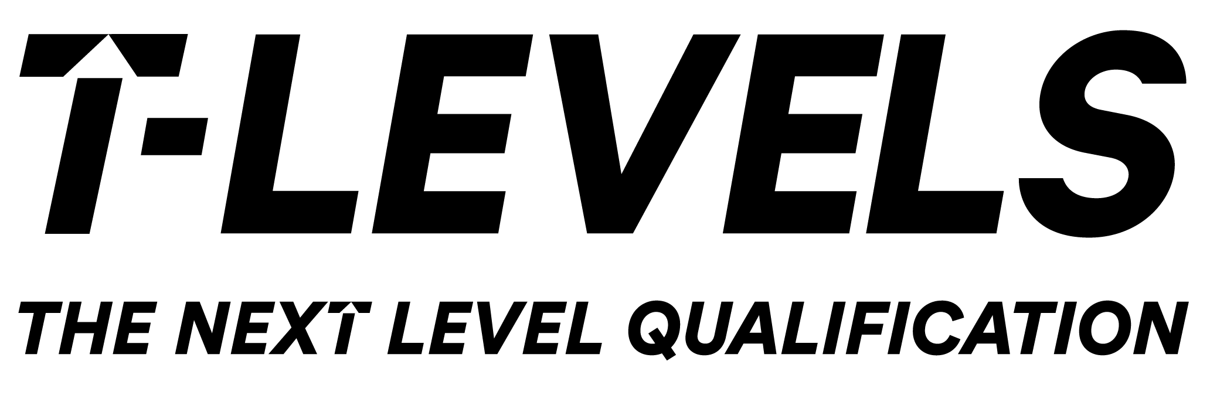

Resources to help with the Employer Set Project Task 4.
et-foundation.co.uk

T Level resource improvement projects (TRIPs)
Final outputs

Scheme of Learning: guidance for staff

Appendix 1: Analysis of scientific posters
Appendix 2: Checklist for poster
Appendix 3: Feedback and evaluation forms
Appendix 4: Presentation slides to accompany scheme of learning
Appendix 5: Teacher guidance for tasks
Appendix 6: Student guidance for tasks
Project title: Developing schemes of learning and learning and guidance materials to develop core skills required for the Employer Set Project.
Organisation: School of Applied Science at Leeds City College
Project finish date: December 2022

Description of outputs
Scheme of Learning: This includes a detailed breakdown of the assessment outcomes, core skills which will be developed in these series of lessons and a breakdown of each lesson. Learning intentions, starter tasks, student activities and teacher guidance have all been clearly explained.
Presentation: Slides are broken down into the four lessons, these are for teachers to guide the students in lessons. Starter tasks and main tasks have all been clearly explained in each of the slides. Learning intentions have also been added to the slides so that staff can explain to students why each lesson is important in order to complete the ESP successfully.
Student worksheets: Three worksheets have been produced for the students to use in these four lessons.

Creation process
These resources have been created after running the ESP at our organisation, recognising what core skills the students needed to improve in order to be successful whilst completing the ESP.
Sessions have been broken down into lessons which can be easily accessed by students and staff.

Sector use
The sector can use this to embed presentation skills with the students further. For example, students going on placement can increase their public speaking, confidence and group work skills while doing the tasks which are in these resources.

Transferability
These resources can be really easily transferred into teaching another T-Level. The only thing a teacher would need to change is the ‘Examples of scientific poster’ to make it more appropriate to the subject being taught.

