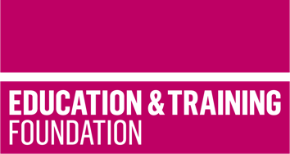
TRIP 19
Brief 4: Materials to support the holistic development of Core Content and Occupational Specialism content for the T Level in Craft and design
This T Level Resource Improvement Project (TRIP) has produced a range of learning materials, developed by an experienced T Level provider. These learning materials will support the holistic delivery of Core Content of the T Level in Craft and design with the Occupational Specialism of Textiles and fashion maker.
Produced by Capital City College Group, this TRIP provides an accessible Framework for Learning, lesson plans and supporting learning materials. Together, these will enable learners to develop knowledge and understanding of Core Skills 2 – Generating ideas, with Core Content Area 4 – Audience and Core Content Area 7 – Equality, diversity and inclusion and Performance Outcome 2 – Plan the production of the required content for different platforms.
The resource includes:
- a Framework for Learning to show the holistic approach to developing knowledge and understanding and how it can be scaffolded and sequenced
- ten lesson plans which cover 20 hours of learning to support the holistic delivery
- learning materials to support each lesson which enables the delivery of the 20 hours of learning.
This resource focuses on the development of evaluative and iterative design skills in a range of textiles and fashion maker contexts. Customer requirement scenarios, case studies, mood boards, design briefs and product outcomes are used to develop these skills. The FfL has been designed to be delivered early in the delivery of the T Level, as a block of learning. It is one approach that could be taken to sequence and scaffold learning.
There are three stages in the FfL:
- Understanding how to analyse and interpret design briefs
- Applying evaluative skills
- Refining evaluative skills through iterative design.
The FfL culminates with a case study and design brief which learners will evaluate and suggest refinements to fully meet the complex requirements of the client brief.
Each lesson has a lesson plan, case studies, handouts and worksheets to support learning. There is a separate slide deck that can be used to support delivery of the ten lessons.

Downloadable resources
Word document including introduction, Framework for Learning, ten lesson plans and associated supporting resources | 1
PowerPoint to support lesson plans | 1

