
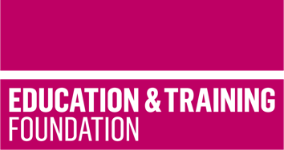

TRIP 13

Materials to support the contextualisation of science content in the T Level in Design, surveying and planning for construction

This T Level Resource Improvement Project (TRIP) has produced a range of learning materials, developed by an experienced T Level provider. These learning materials will support learners to develop the Core Skill of Communication for the T Level in Design, surveying and planning for construction.

Produced by Leeds College of Building and peer reviewed by Weston College, this TRIP provides an accessible framework for learning, lesson plans and supporting learning materials that will enable learners to apply scientific concepts, techniques and principles to the Core Content of the T Level in Design, surveying and planning in construction.

The resources include:
- a framework for learning to show how the contextualised science content can be scaffolded and sequenced
- ten lesson plans which cover 30 hours of learning to support the development of the Core Skill of communication in conjunction with Core Content
- learning materials to support each lesson which enables the delivery of the 30 hours of learning
- guidance that can be provided to learners to demonstrate how they can use their skills as part of the Employer-set project (ESP) assessment.

The focus of the resource is the degradation and failure of metals, specifically the following metals:
- steels (mild, stainless, high-strength)
- aluminium alloys
- copper
- brass

The overall outcome of the learning from this resource is for learners to select the correct metal materials for industry applications using informed knowledge about potential degradation based on extrinsic factors.

This resource supports contextualisation of the science content:
2.1 understanding material properties, chemical composition, degradation, failure and effects of environmental conditions.

It also supports the development of:
Core Skill 4: primary research.

To maximise learning, the lessons assume prior knowledge of:

- Hooke’s law
- primary research
- data gathering
- science report writing
- mathematics – basic arithmetic functions.

Each lesson has a lesson plan and resources to support learning. There is a separate slide deck, with animation that can be used to support delivery of the lessons.

Downloadable resources

Word document including introduction, framework for learning, lesson plans and associated supporting resources | 1
PowerPoint to support lesson plans | 1

