
TRIP FEASIBILITY STUDY:

DIGITAL AND BUSINESS INDUSTRY PLACEMENTS INTO FOOTBALL

Written by: Simon Bone – Work Placement Manager, Weston College

Contributors:
Matt Lyons – Digital Lead, Weston College
Jonathan Pik – Somerset County FA
Brendan Dix – Somerset County FA
Oli Bliss – Weston-super-Mare FC
Alex Crowther – Weston-super-Mare FC
Kevin Sturmey – Taunton Town FC
Ewan Greenhill – Bridgewater United
Oli Moore – Bridgewater United

Date of publication: July 2021



SUBSTANCES
context, scope and vision 2
understanding t levels 2
Structure of a T level: 3
T Levels Digital 3
T levels Business 3
understanding industry placements 4
What is an industry placement: 4
Industry placement core principles: 4
Industry placement completion: 4
key competencies/knowledge, skills and behaviours framework (ksb) 5
Key Digital T Level KSB: 5
example activities for the sector (including mapping to t level) 7
Digital T Level Example Placement Activities/Projects: 7
Business T Level Example Placement Activities/Projects: 8
barriers/challenges/solutions 9
Wider Employer Insights – shaping future skills 10
Benefits to Employers/Maximising the opportunity- recommendations 11
Making the most of a T Level Industry Placement to benefit your business and the young person you host: 11
EVALUATION 11
Project timeline 12

context, scope and vision
We created a working group to undertake a feasibility study into the suitability of football leagues / clubs, becoming hosts for digital or business industry placements (IP). The group looked at the skills, knowledge and behaviours (SKB) required within the T Level specifications and then mapped out possible activities / tasks the students could undertake when carrying out their placements at the clubs, which could provide opportunities to apply the skills learnt in the T level programme. The end goal was to create a guide/competency framework to support IP for use in a football business setting, as set out in this document.
The football landscape is pyramid shaped with a very small professional tier opening out into a much larger semi-professional and voluntary industry beneath it. We have assessed the ability of football clubs in the lower and middle tiers of the industry to provide high-quality placements, that could potentially create a vast number of opportunities for T Level students to experience and progress to skilled work in the sports industry.
The intent of the project was to ensure that employers can access future talent by bringing young people into their organisation on sustainable and high-quality T level industry placements. Employers will be able to utilise this resource for guidance. Ultimately students will be able to gain access to relevant and high-quality placements that meet both demands of the T Level and sector requirements for that employer, and a chance to hone skills in a real-world setting.
It is widely recognised by both the FA and Sport England that football / sports clubs and leagues must evolve their existence and develop their operations in order to stay relevant and financially sustainable - particularly with a digital focus. As such, a skilled workforce is needed to help digitalise club services and offers. There is therefore a real opportunity to bring together college T Level providers and clubs to solve this issue for the industry whilst opening up many more potential placement settings for students.
It is important that the details of the possible placement tasks and projects are discussed between providers and employers, thus deepening the understanding of how all stakeholders can benefit from these opportunities. We have tried to ensure that the guide is written in the right language to ensure that the opportunity resonates with both the prospective football employers and the FE sector. There is potential for thousands of digital and business placements across the grassroots game, semi-professional and professional clubs, and leagues across the country, whilst also making a genuine difference to the football / sports sector.

understanding t levels
T Levels are new, two-year, technical study programmes, designed with employers to give young people the skills that industry needs now and in the future. T Levels will provide a mixture of:
- technical knowledge and skills specific to their chosen industry or occupation
- an industry placement of at least 45 days (315hours) in their chosen industry or occupation
- relevant maths, English, and digital skills.
T Levels will become one of three options when a student reaches level 3, alongside apprenticeships for students who wish to study and train for a specific occupation ‘on the job’, and A levels for students who wish to continue academic education.

When they complete a T Level study programme, students will be able to choose between moving into a skilled occupation or further study, for example, a higher or degree level apprenticeship, or higher-level technical study, including higher education.
Technical education has been categorised into fifteen different technical routes, according to occupational specialism. T Levels will be available across eleven of those routes, with occupations in the remaining four routes accessible through an apprenticeship only. Most routes have been split into a number of specialist pathways. The occupations within scope for each T Level are set out in the Institute of Apprenticeships’ occupational maps. https://www.instituteforapprenticeships.org/occupational-maps/

Structure of a T level:
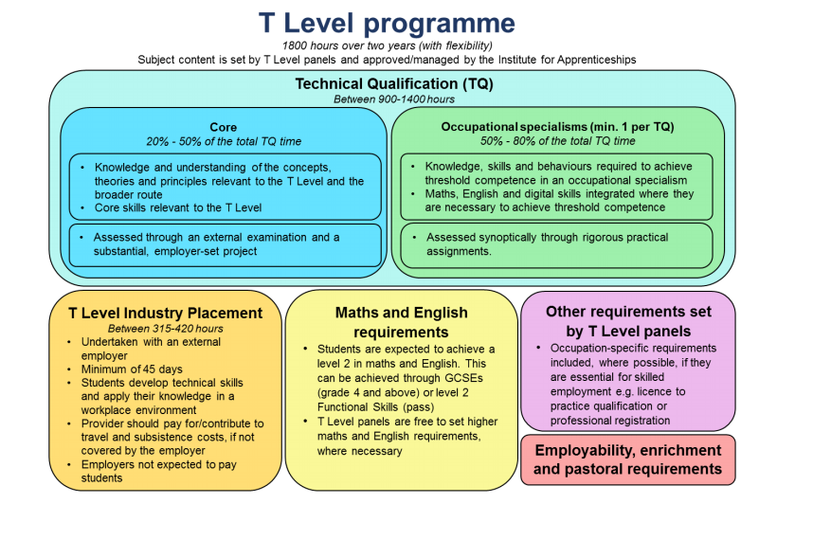

T Levels Digital
Outline content for the routes can be found here:
https://www.instituteforapprenticeships.org/media/2942/digital-production-design-outline-content.pdf
https://www.instituteforapprenticeships.org/media/2946/digital-business-services-final-outline-content.pdf
https://www.instituteforapprenticeships.org/media/2947/digital-support-services-final-outline-content.pdf

T levels Business
Outline content for the routes can be found here:
https://www.instituteforapprenticeships.org/media/4041/final_ma_outline_content_itt_march2020.pdf

understanding industry placements

What is an industry placement:
An industry placement is a shift from traditional work experience to a longer, more structured placement in an external workplace, for young people to develop real work skills and make a meaningful contribution to an organisation.
Industry placements a mandatory element of the new T Level qualifications, employers are partnering with local colleges to host industry placements to support their business. Industry placements give employers a chance to work alongside the next generation of workforce entering industry, making sure they develop the knowledge, behaviour, and practical skills to succeed.

Industry placement core principles:
- Takes place in a working environment: must be external to students’ normal learning environment so they experience what it is like to be in a real-life job, including travel to work, independence from their peers and working with new people, except for students with SEND or in Young Offender Institutions where alternative approaches can be applied. Placements cannot be delivered virtually/remotely.

- Relevant to the occupational specialism: must be focussed on developing up-to date technical skills and specialist knowledge required for the students’ occupational specialism, which is underpinned by the qualification content that students are studying at Level 3. However, students studying Digital and Engineering & Manufacturing T Levels can undertake a route level placement that allows them to develop the knowledge and skills studied at route level rather than those only relevant to their occupational specialism.

- Number of employers: a placement can be split across 2 employers, where this is considered necessary for ‘breadth of content’ and/or beneficial for students

- Duration: must be for a minimum of 315 hours (there is no upper limit), which can include up to 35 hours of work taster activities, if relevant to all the occupational specialisms within the T Level. The only exception currently is the Early Years Educator occupational specialism, within the Education and Childcare T Level, that must be for a minimum of 750 hours

- Timing: must be organised in line with the normal requirements of the industry, which may be outside the academic timetable or normal provider working hours. Placement hours must align with the Working Time Regulations.

Industry placement completion:
To complete their placement students must:

- demonstrate sufficient progress towards their learning goals
- work directly with an external employer and
- have been on placement for the minimum number of hours
Key concepts and considerations for Industry placement:
- Student readiness: providers must ensure students are suitably prepared to enter the workplace before they go on their industry placement. This includes having the required technical and employability skills and knowledge, including a good understanding of the professional standards of behaviour and attitude they need to display on their placement and the importance of adhering to company policies and procedures.

- SEND accessibility: providers and employers must comply with their legal duties under the Equality Act 2010, including provisions for reasonable adjustments, so that students with Special Education Needs and Disabilities (SEND) can benefit from high quality external industry placements as much as their non-SEND peers.

- Placement structure: there is not one fixed model for delivery and placements can take place over a block, day release or a mix of both. A series of allowable general and route specific models can also be adopted to ensure placements are accessible for all students and deliverable across all industries.

- Student safeguarding: providers must be satisfied workplaces are a safe working environment for students, that employers are complying with their responsibilities, and students’ wellbeing is checked via regular review meetings.

key competencies/knowledge, skills and behaviours framework (ksb)
We have developed the following resource, with the aim to ensure that all stakeholders get the opportunity to benefit from T Level Industry Placements. There are many benefits to our learners, including improving their employability and technical skills and getting invaluable experience from industry - all of which that form a key part of college life and the learner journey through college. As well as wider college benefits such as those for our wider regional and national partner businesses, in preparing the workforce of the future and enabling early access to the next generation of talent, moving into sectors.
As a core part of the T Level programme students are prepared for their industry placement throughout the first year of their study programme, thus ensuring that when they engage in placement they have a good understanding of the professional conduct/behaviours expected of them on placement. They will also have been taught some technical skills that they will then be able to utilise whilst in placement. It is recommended that employers engage with student early prior to placement starting to impart their own values and ethos to students, this becomes art of the matching process and will help ensure successful placements.

Key Digital T Level KSB:
Knowledge |  | Skills |  | Behaviours
Business Context  - Risk  - Impact  - Customers  - Profile |  | Website development/ Software Development |  | Effective Communication and Interpersonal skills
Digital Environments  - Networks  - Systems  - Software |  | Digital Communications and Tools |  | Team player
Data  - Capture and Utilisation |  | Creativity- Bringing fresh ideas and perspectives to the table |  | Readiness for work  Commercial Awareness
Digital Analysis  - Algorithms and problem solving |  | Hardware  Networks  Cabling  Install |  | Resilience
Legislation  - ISO  - Data Protection |  | Software Support  Front/Back End  Storage |  | Analytical thinking
Knowledge |  | Skills |  | Behaviours
Security  - Confidentiality  - Risks/Threats Management |  | App development |  | Reflection and willingness to learn
Digital Testing  - Testing all digital components |  | Risk Management and Digital Processes  Cyber Security |  | Right Attitude
Digital Tools  - Presentation  - Evaluation  - Communications |  | Digital Problem Solving and finding digital solutions |  | Organisation and Time Management
Learning  - Creativity  - Design  - Problem Solving |  | Data Capture, Utilisation Analysis and Presentation |  | Commitment

Knowledge |  | Skills |  | Behaviours
Business Context  - Economic and Social Impact  - Legislation  - Stakeholder Management |  | Research and Data Utilisation |  | Effective Communication and Interpersonal skills

Knowledge |  | Skills |  | Behaviours
People  - Motivation  - Retention  - Profile  - Team dynamics and performance |  | Problem Solving &  Presentation and Reporting skills  Effective use of Planning tools |  | Team player
Quality and Compliance  - ISO  - Quality Improvement |  | Stakeholder Management  Marketing and Promotion |  | Readiness for work  Commercial Awareness
Finance  - Budgeting |  | Quality Improvement Process Management |  | Resilience
Policies and Procedures  - Legislative  - Operational  - Organisational |  | Business Performance monitoring and improvement |  | Self-Management
Project and Change Management |  | Leadership and Management  Strategy  Project Management |  | Reflection and willingness to learn
Business Behaviours  - Effective Communication  - Ethos and Values |  | Effective Verbal and Written communications |  | Organisation and Time Management

*Business learner skills journey to be added once the T Level specification has been finalised in readiness for Business T Level launch in September 2022.

example activities for the sector (including mapping to t level)
T Level Digital and Business students can support the following outcomes:

- Increase attendance/customer base by x %
- Increase revenue by x %
- Increase digital traffic on website by x %
- Produce an App to increase client/media reach by x %
- Improve Data collection and Utilisation to ensure targeted marketing and research.
- Increase social media engagement by x %
- Improve and Support Business Functions
- Develop Digital Processes
- Support and Manage Projects

Digital T Level Example Placement Activities/Projects:
Activity | Curriculum Mapping
Website Development- Club/League (2+ Students) (up to 12-month project)  - Updates and increased engagement  - E-commerce  - Data collection  - News/media  - Navigation improvements/Usability  - Increased website hits  - Front/Back end Support and Development  - Advertising/sponsorship  - Improved communications | Occupational Specialism  Core 4  Core 8
App Development (2+ students) (12-month standalone Project)  - Push notifications- Matchday and announcements  - E-commerce  - Data collection  - News/media  - Advertising/sponsorship  - Improved communications  - Promotions | Core- 1-2  Occupational Specialism  Core 4  Core 8
Digital Media and Marketing Support (1+ Students)  - Attract new customers/players/Sponsorship  - Support Social Media Pages  - Digital Business Advertising | Core- 3-5
Digital Processes Development (1+ Students)  - Remove paper-based process  - Digitise processes to improve efficiency  - Volunteer structure | Core- 3-5
Data collection/Utilisation and Management (1+ Students)  - Research LMI  - Utilise data to improve marketing and organisational functions  - Presenting visual data | Core- 6  Occupational Specialism
Back office and ICT functionality- Hardware and Software (1+ Students)  - Infrastructure development and support  - Efficiency  - Networking  - Helpdesk support- Grassroots engagement with Key stakeholder websites such as: County FA, FA Fulltime etc. | Core- 7-8
Matchday data support (1+ Students)  - Collection/Capture and Utilisation of Data  - Trends  - Support Targeted marketing and business function | Core- 6
Grounds and Maintenance Digitalisation (1+ Students)  - Pitch and Ground Maintenance scheduling  - PPM scheduling | Core- 3-5  Core- ESP
Supporting Grassroots Club Development (1+ Students)  - Supporting County FA/Leagues to provide digital support to clubs without infrastructure to physically host a student  - Support in creating commercial partnerships to support grassroots | Core-3-5

Business T Level Example Placement Activities/Projects:

Activity | Curriculum Mapping
Project Management (1+ Students)  - Support for new projects and ideas  - Task and Finish through placement  - Research and Development  - General and Specific support | To be mapped once qualification specification is approved
Social Media and Marketing Support (1+ Students)
- Attract new customers/players
- Content Design
- Communications support
- Planning and Delivery
Commercial Development (1+ Students)
- Account management and building relationships with stakeholders and suppliers
- Creating commercial partnerships to support grassroots clubs
- Attracting new sponsorship/customers
- Supporting and Promotion of club/regional and national initiatives
Business function support (1+ Students)
- Administration
- HR
- Finance
- Marketing/Media
- R & D and Evaluation
Matchday support (1+ Students)
- Improving public image
- Improving matchday experience
Marketing and Social Media Support
- Social Media Planning and content creation
- Targeted Marketing, using researched data

barriers/challenges/solutions

Barrier/Challenge | Solution
Cost | Employer Incentive to support in AY 21/22- £1000 per industry placement hosted. This fund can help bridge initial infrastructure costs that may be needed.
Physical Workspace | Can be hosted by County FA’s, Larger Clubs to support those without infrastructure in place such as grassroots clubs. This hub model will be trialled in AY 21/22.
Mentoring/Supervision | Mentor training can be offered from Provider to support direct line managers and supervisors.
Ongoing Support | Single point of contact from Provider to manage relationship, provide ongoing placement support to employer and student and troubleshoot as required, thus ensuring successful IP.
Remote Working | Not allowable at this stage. Blended approach consideration/elements of remote support/working could be considered. Hub and centralised model through County FA’s and Larger Employers seems most feasible at this stage.
Technical expertise to support the student | Tech Mentor to be sought/Build tech support into curriculum timetable/Initially support college tutors. Wider consideration into this required this ensuring high quality and meaningful industry placements are sustainable. It will also be prudent to explore external partner tech support for students whilst on placement and to offset where this cannot be sourced in house, within the industry.

Wider Employer Insights – shaping future skills
Employers could also offer additional value to students via:
- Careers talks
- Setting project briefs (Individual and group) (live and simulated)
- Attend Careers fairs / conventions to showcase industry
- Support Mock interviews
- Arrange Ext Employer visits to their workplace
- Offer Industry insights to curriculum
- Contribute Guest lectures and Employer masterclasses
- Business mentoring
- Employability workshops / events
- Industry Advisory Board – identifying future skills demand and shaping future curriculum

Benefits to Employers/Maximising the opportunity- recommendations
Paperless Process
Ease of access for employers to host IP’s. Provider will monitor placement through online placement platform and regular face to face visits
Support Business Needs Supporting operational demands/projects.
Providing resource where required
Dedicated Communications line
Single POC from provider to ensure effective communications. Fully supported journey for all stakeholders

Robust Induction and
Training Programme
Learners will be comprehensively prepared for the workplace through their provider
Competency Monitoring
Provider will ensure a placement competency mapping system is in place to ensure successful placement and that the student can fully utilise their skills to benefit the business
Workforce Talent Pipeline
Developing your future workforce and planning for your future skills need

Employer Incentive – Gov. have announced £1000 to employers for hosting T Level IPs in AY 21/22- details tbc.

Making the most of a T Level Industry Placement to benefit your business and the young person you host:

- Conduct an Employer Needs Analysis
- Identify your digital and business needs as an organisation and map out how a student can support you in line with skills set out in tables above.
- This will enable you to identify where you have gas in your resource that may be filled by an industry placement student.
- Access the support available to employers including contacting your local provider.
- Providers will support employers through the whole journey from initial matching and recruitment through to placement completion. The idea is that this will support a sustainable pipeline of talent from local providers into the sector.
- Next steps are to have a conversation about your needs with your local provider.

EVALUATION

We brought together several key regional stakeholders, along with two prominent regional FE settings, to help realise a regional view of the sector from a placement perspective, with the accompanying resource, we feel that this should be a pre-cursor to a more national approach, with endorsement sought from all levels of the game including the FA and Premier League.
The concepts/themes and resource discussed and created are inclusive and will ensure that placements can be made available to all students studying these T level routes. A natural progression may be that the resource created can expand into wider sports business settings across the country.
The key outcome resource, (competency, KSB framework, guidance document) from this study can be shared with the quality teams and key curriculum stakeholders to ensure that best practice is shared, and all proposals meet the requirements of the T level qualification and Employer partners, thus ensuring high quality placement opportunities being sourced with football employers.
We have found that at this initial stage further conversations will be required based on specific business need, however early indicators suggest that it is indeed feasible to host industry placements for digital and business learners in the football sector, subject to having the right modelling (this may mean hub placements at larger employers/County FA’s that support a network of smaller employers/clubs). Our employer stakeholder partners have signed off the resource document ascertaining that it is feasible for these types of placements and have made suggestions for the engagement of industry placements that could provide reciprocal benefit across the sector.
Placements will be trialled from next AY21/22 and ongoing review and findings will help shape continuous quality improvements for us as providers and our employer partners, with the long-term view will be of this resource being shared nationally to football settings across the country.
Stakeholder Quotes:
“The value that an industry placement student can bring to any business cannot be underestimated; the challenge that we have is that industries do not currently know what a T level student is capable of from a skills point of view. This resource will open up bespoke conversations and form partnerships between providers and employers, thus ensuring that digital industry placements can thrive”.
“There is a need for the sector to update its working practices and become more digitised. As an employer we are run by a significant number of volunteers, so to be able to access students to support us become more digitally focussed, would be of great benefit”
“The football landscape is pyramid shaped with a very small professional tier opening out into a much larger semi-professional and voluntary industry beneath it. This project will be able to assess the ability of football clubs in the middle tiers of the industry to provide high-quality placements, potentially creating a vast number of opportunities for T Level students to be placed in the sports industry.”
“Hosting industry placements could support our marketing and communication officer and associated projects, as well as enable us to consider future recruitment based on the skills we need”.

Project timeline
The timeframe of this project was as follows. This could be replicated and scaled up to look at feasibility across the country and in wider industry settings:
- We began in early June with the view of gathering all stakeholders for an initial meeting to discuss the project and key themes.
- During the initial meeting key curriculum staff identified and explained the T level and associated skillsets that students could present to the employers from the Key T level strands of Digital and Business.
- Employers then identified where this support could benefit their business and outlined any initial barriers that may present, for discussion. From the initial meeting actions were identified and a review was undertaken to gather understanding from those key external stakeholders to help bridge the gap between our T level learners and the industry.
- The resource as below was produced to be a guide to help employers engage with the Digital and business T level learners that will give examples of tasks and activities that will be beneficial to all parties involved.
- A follow up meeting was undertaken to review this document and proposals were presented from the FE partners for discussion with the employer stakeholders. Refinements will continue to be made on this draft resource and a positive view of the feasibility shared with regional employer stakeholders and beyond as the project evolves.
- A final meeting was conducted in early July to finalise the key outcome documents/resources with the hope that in time this could be mirrored across the industry as an example of good practice that supports the bridging of these T level routes into the wider industry and helps providers source long term high quality and sustainable industry placements.
- Following the final meeting we have identified trial opportunities for Digital industry placement that will begin in AY 21/22 to fully test the example placement activities below and to measure the impact that the placements have for both the student and the business.
Additional Resources
Information from the following sources can be used to support and develop wider understanding of the T Level agenda and are useful follow up tools to this feasibility study:
https://employerindustryplacements.co.uk/
https://www.gov.uk/government/publications/employer-incentive-payments-for-employers-offering-a-t-level-industry-placement
https://www.gov.uk/government/publications/t-level-industry-placements-delivery-guidance/t-level-industry-placements-delivery-guidance#section4
https://www.instituteforapprenticeships.org/t-levels/approved-t-level-technical-qualifications-and-final-outline-content/final-outline-content/
https://www.aoc.co.uk/sites/default/files/Employer%20information%20guide.pdf



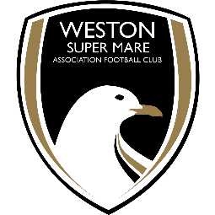

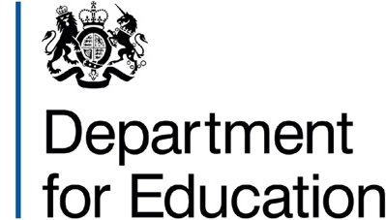

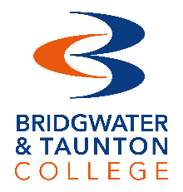
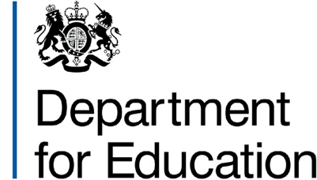


THANK YOU

Our Partners Funded by

