
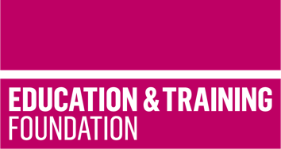

TRIP 9

Produce employer co-created case studies and learning materials to support the delivery of the T Level in Digital production, design and development Core Content

This T Level Resource Improvement Project (TRIP) has produced case study materials, and a range of learning materials to support the delivery of T Level in Digital production, design and development Core Content and Core Skills. The case studies and learning materials have been developed by an experienced T Level provider, with input from employers.

Produced by Shrewsbury College, this TRIP provides an accessible framework for learning, lesson plans and supporting learning materials that will enable learners to develop understanding of key concepts in the Core Content for the T level in Digital design, production and development.

Shrewsbury College worked closely with two employers to develop the case study materials. The case studies develop throughout the delivery of the lessons. From the outset, learners are introduced to the project’s context, its objectives and the real-world implications of their work. As the lessons progress, they delve into various aspects of project development, including planning, design and implementation, mirroring the stages of actual information technology (IT) projects. This case study journey is tailored to mirror the demands and realities of the programming, project management and cybersecurity industries, making it particularly relevant for learners in these fields.

All TRIP materials are designed to support contextualised understanding of following Core Content Areas
- 2 Programming
- 4 Legislation and regulatory requirements
- 5 Business context
- 8 Security.

The resources include:
- a framework for learning to show how learning can be scaffolded and sequenced to develop understanding
- case studies materials to support the scaffolding and sequencing of learning
- nine lesson plans to support the scaffolding of the understanding of Core Content
- learning materials to support each lesson which enables the delivery of the framework for learning.

The framework for learning focusses on:

- project risks, constraints and dependencies
- resource planning
- design
- communication
- abstraction
- algorithms
- user interface design
- security
- reflection
- review.

As well as the case studies, which provide contextualised learning, the learning materials to support each lesson include task sheets, templates and activities.

The is also a separate slide deck to support the lessons.

Downloadable resources

Word document including introduction, framework for learning, lesson plans and associated supporting resources including case study materials | 1
PowerPoint to support the lesson plans | 1

