
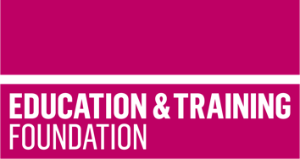

TRIP 8

Produce employer co-created case studies and learning materials to support the delivery of T Level Management and Administration Core Content

This T Level Resource Improvement Project (TRIP) has produced case studies, and a range of learning materials to support the delivery of T Level Management and Administration Core Content and Core Skills. The case studies and learning materials have been developed by an experienced T Level provider, with input from employers.

Produced by Franklin College, this TRIP provides a framework for learning, lesson plans, case studies and learning materials to support contextualised understanding of Core Content area 4: Finance and Core Skill D (CSD): Working collaboratively with others.

The resources include:
- a framework for learning to show how learning can be scaffolded and sequenced to develop understanding
- case studies to support the scaffolding and sequencing of learning.
- seven lesson plans which cover 21 hours of learning to support the scaffolding of the understanding of Core Content.
- learning materials to support each lesson which enables the delivery of the 21 hours of learning.

The framework for learning and supporting lesson plans provided in this resource cover the following Core Content:
- the role of financial reporting to organisations.
- the different areas of financial reporting and how these differ (e.g., income/sales and spend/costs).
- the range of report types including balance sheets, profit and loss accounts, management accounts, year-end reporting, and cash flow.
- the purpose of financial reporting.
- the importance of financial reporting and its accuracy.
- basic profit and loss calculations, including gross and net profit and profit margins. How they are calculated using different formulae
- the concept of and calculation of break-even point.
- how financial reports are generated.

As well as the case studies, which provide contextualised learning, the learning materials to support each lesson include task sheets, templates and activities.

The are also separate PowerPoint slides to support the seven lessons.

The framework for learning and lesson plans also covers the following General English and Maths Competencies (GECs and GMCs):
- GEC6 Take part in/lead discussions
- GMC2: Estimating, calculating and error spotting

Downloadable resources

Word document including introduction, framework for learning, seven lesson plans and associated supporting resources including case studies | 1
PowerPoint to support the lesson plans | 1

