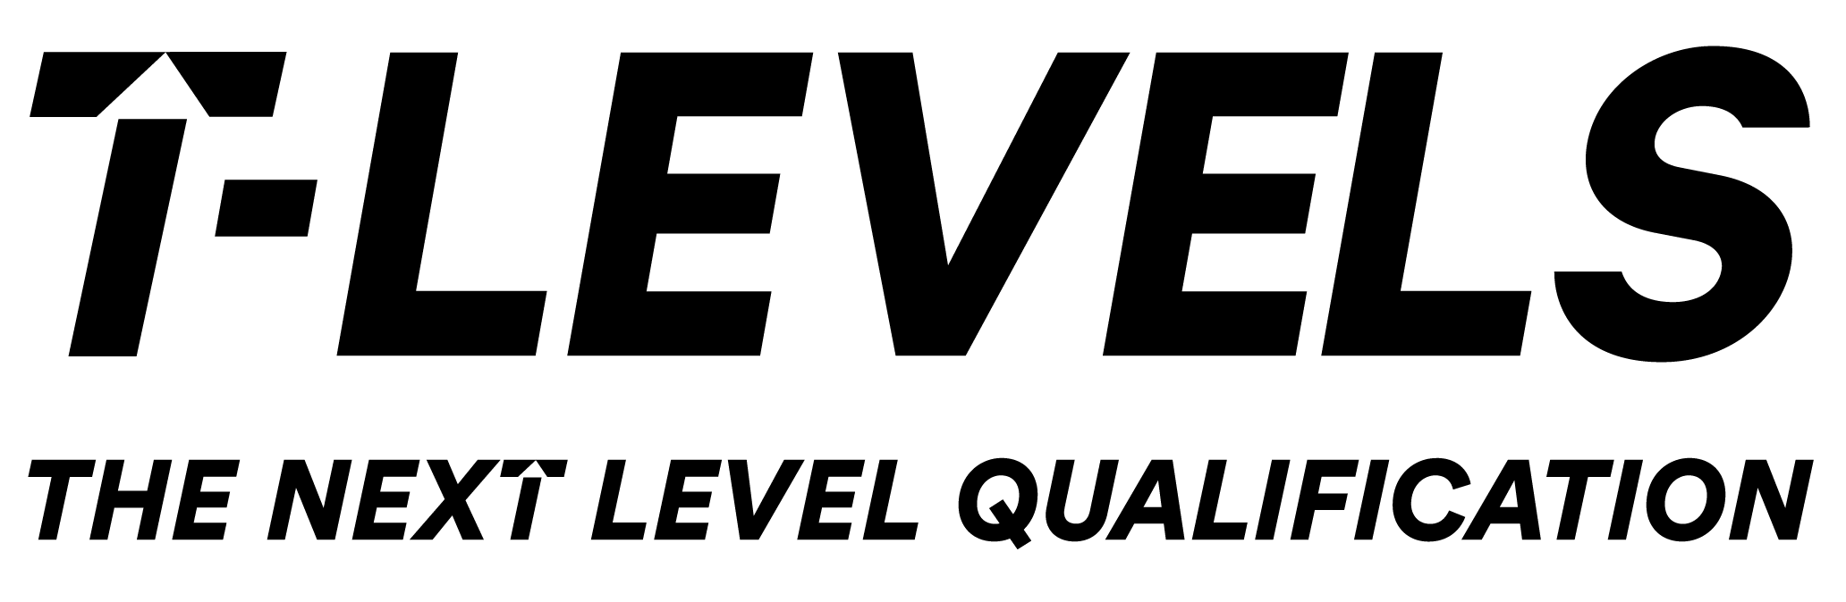
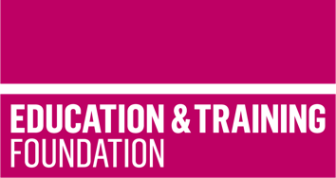

TRIP 2

Materials to support the development of Core Skill three for the Employer Set Project in T Level Education and Early Years

This T Level Resource Improvement Project (TRIP) has produced a range of learning materials, developed and peer reviewed by experienced T Level providers. These learning materials will support learners to develop Core Skill three of the T Level in Education and Early Years.

Produced by Warrington and Vale Royal College and peer reviewed by Eastleigh College, this TRIP provides an accessible framework for learning, lesson plans and supporting learning materials that will enable learners to hone and develop Core Skill three in conjunction with developing understanding of Core Content of the T Level in Education and Early Years.

The resources include:
- a framework for learning to show how learning can be scaffolded and sequenced to develop Core Skill three.
- ten lesson plans which cover 20.5 hours of learning to support the scaffolding of the development of Core Skill three in conjunction with Core Content.
- learning materials to support each lesson which enables the delivery of the 20,5 hours of learning.

Core Skill three requires learners to use formative and summative assessment to track children’s and learners’ progress and thereby plan and shape educational opportunities. These resources focus on the use of formative assessment to support the development of children in early years settings. The ten lessons included in this resource are organised into four phases, these are:
- formative assessment
- assessment using observation
- writing observations
- analysing observations

The framework for learning and supporting lesson plans provided in this resource cover the following Core Content:
- monitoring and recording children’s / young people’s achievement
- formative assessment
- summative assessment
- identifying developmental progress
- informing planning for children’s / young people’s next steps
- maintaining the validity and reliability of information
- observing, recording and reviewing children’s progress.

The learning materials to support each lesson includes templates for narrative and snapshot observations, example observations, activities and cases studies.

The separate PowerPoint slides support the ten lessons and include embedded videos to use within the lessons.

The framework for learning and lesson plans also cover the following General English and Digital Competencies (GECs and GDCs):
- GEC1: Conveying technical information to different audiences
- GEC3: Creating texts for different purposes and audiences
- GDC1: Using digital technology and media effectively.

Downloadable resources

Word document including introduction, framework for learning, ten lesson plans and associated supporting resources | 1
PowerPoint to support lesson plan including embedded videos | 1

